Artalu Ladder
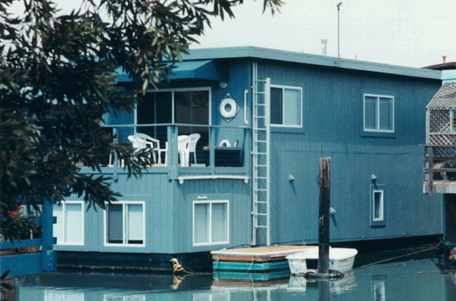
A more simple design than the Jomy Ladder, the Artalu (or Mini-Jomy)
is narrower, lighter, has no guard rail and uses a basic catch system
to open and lock the ladder. In other respects this ladder follows the
same structural concepts and manufacturing quality as its larger
relative.

Rungs are tensioned with stainless steel springs to enable effortless
closing, regardless of ladder height.

Burglar-proof: cannot be opened without the release of the latch.
Can be locked at ground level for access applications.

Stainless steel pivot pins with nylon bushings prevent metal to metal contact and reduce corrosion.

Simple release catch. Even a child can easily open the ladder.

Can be mounted at a 105 degree angle (optional) to provide more shoulder space.

Because the ladder remains closed when not in use, ice and snow cannot accumulate on the rungs.

Cap prevents water from entering the ladder column providing maintenance free operation.

