Jomiro Descent Systems
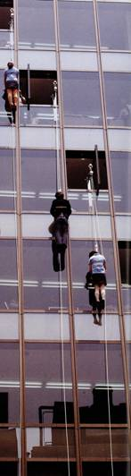
Safety tested under all operating conditions.

Ease and simplicity of operation, anyone can use it.

Single person operated, no assistance required.

Simply attach the steel loop of the speed regulator to the ring of the support structure and secure the safety harness around your upper body. The operator can now quickly lower themselves to the ground without the assistance of others, regardless of weather conditions.

Due to the centrifugal brake and patented planetary gear design, the danger of a hard landing is eliminated. People of all ages and weight can descend about the same speed thus eliminating any landing shocks. The elderly, disabled, and children can all confidently use this system.

As one person descends the second harness attached at the opposite end of the cable is automatically pulled to the top for use by the next person. An unlimited number of people can safely descend one after the other in this fashion.

Jomiro can be installed in or near any opening large enough for a body to pass through. If the location of initial installation becomes unsafe during an emergency, simply detach the portable speed regulator and carry it to a safer location which must already have been fitted with a suitable mounting point.

